
School Of Computing and Informatics
Website Design and Development
Assignment 1
Student Name: Huda AL-Falah
Student ID: 22220033
Section Number: Website & Development 3
GitHub Link: https://github.com/HudaALFalah333/laprima-final/settings/access?guidance_task=

Website Link: laprimacouture.kesug.com

Contents
1. DNS 2
1.1 Types And Purpose Of DNS 2
1.2 How Domain Names Are Organised and Managed 2
2. Communication Protocols, Server Hardware, Operating System, And Web Server Software 2
2.1 Communication Protocols Definition 2
2.2 Relationship Between Protocols, Hardware, Operating System, Web Server Software 2
2.2.1 Purpose And Relationship 2
2.2.2 Relation To Designing, Accessing, and Publishing the Website 2
3. Website Development Technologies, Tools, Techniques, And Frameworks 2
3.1 Website Development Technologies 2
3.1.1 Available Website Technologies 3
3.1.2 Technologies Used to Design, Develop and Manage Your Website 3
3.2 Website Development Tools 3
3.2.1 Available Tools for Website Design and Development 3
3.2.2 Tools Used to Design and Develop Your Website 3
3.3 Website Development Techniques 3
3.3.1 Available Techniques for Website Design and Development 3
3.3.2 Techniques Used in Your Website 3
3.4 Website Development Frameworks 3
3.4.1 Available Frameworks for Website Design and Development 3
3.4.2 Frameworks Used in Your Website. 3
4. Search Engine Optimization 4
4.1 Search Engine Optimization Definition and Purpose 4
4.2 Indexing Definition 4
4.3 Techniques For Improving the Ranking 4
4.4 Evidence For the Used SEO Techniques in Your Website 4
5. Front-End And Back-End Website Technologies 4
5.1 Front-End And Back-End Definition and Related Technologies. 4
5.2 Presentation And Application Layers Definition. 4
5.3 Relationship. 4
6. Online Website Creation Tools VS Custom-Built Websites 4
6.1 Online Website Creation Tools 4
6.2 Custom-Built Websites 4
6.3 Comparison With Regards to Design Flexibility, Performance, Functionality, User Experience (UX) And User Interface (UI). 4
7. Design And Development Process 5
7.1 Website Vs. Design Document 5
7.2 Evaluation and Analysis 5
Hosting 5
References 5

DNS

Types And Purpose Of DNS
What is DNS?

The Domain Name System (DNS) can also be described as the internet phone directory. It is a disguised name that converts easily understandable domain names which are easily understood by man (www.google.com) into numerical IPs (ex-192.168.1.1) that are understood by the computers allover the internet. In the absence of DNS users would need to remember IP address in order to get connected to the specific website.

Purpose of DNS
The DNS has several critical functions that contribute to the seamless functioning of the internet:
- Translation of Domain Names into IP Addresses:
Translates domain names that are easy for people to remember into numerical IP addresses for easier recognition by computers when searching for sites.

- Connection Between Devices:
This feature allows users to connect to the right web servers depending on their domain queries to ensure that datas are channeled correctly.

- Caching for Faster Access:
Increases the rate of browsing by caching previous resolved domain queries to enhance their future use.

- Domain Management:
Helps in the coordination and distribution of domain names to give dependable and regular service.

Types of DNS
The DNS system is composed of several types of servers, each playing a specific role in the process of resolving domain names:

- Recursive DNS Resolver:
Serves as an agent to the user and automatically communicates with the other DNS servers. Carries out repeated queries to obtain the correct IP address associated with a given domain name.

- Root Name Server:
The first in its kind in the DNS lookup mechanism. It is responsible of giving clues to the Top-Level Domain (TLD) name servers such as the .com or .org name servers.

- TLD Name Server (Top-Level Domain):
Those that are in charge of domain extensions such as com, net as well as org. Tells the user queries to go to the correct authoritative name server.

- Authoritative Name Server:
The physical record of domain names and the corresponding DNS record types such as A, AAAA, MX, CNAME, and such. Returns the IP address of the requested domain in response to DNS look up queries.

How Domain Names Are Organised and Managed

Domains are organized and managed in a hierarchical system for efficient operation and consistency on the internet. The following aspects summarize how such domain names are structured and maintained.

Hierarchy of Domain Names:
- Root Level: This is the topmost level of the DNS hierarchy represented as an empty string or a dot ("."). It points at the servers of the top-level domain (TLD).
- Top-Level Domains (TLDs): These include generic domains like .com, .org, and .net together with those specific to countries like .uk and .jp.
- Second-Level Domains (SLDs): These are the custom names which are chosen by the domain registrant, such as google in google.com.
- Subdomains: These are levels created under an SLD, like mail.google.com.

Domain Registration:
- Accredited registrars are responsible for domain registrations and are overseen by the Internet Corporation for Assigned Names and Numbers (ICANN).
- Domain names can be purchased and renewed by registrants for a period of time, which usually is one year or more.

DNS Records Management:
- There are DNS records associated with a domain (A, AAAA, CNAME, MX), specifying the way requests go through.
- Such records are hosted at authoritative DNS servers and may be updated by domain administrators.

Role of ICANN:
- In general terms, ICANN facilitates specifying the coordination of issuing and administering domain names and IP address space worldwide.
- It helps to ensure that every domain name is unique, and correctly attached to its relevant IP address.

Renewal and Maintenance:
- A domain name is maintained and owned as long as the owner continuously renews such registration.
- The domain will, thereafter, become subject to other purchases in the event of failure to renew.

Communication Protocols, Server Hardware, Operating System, And Web Server Software

Communication Protocols Definition
Communications can therefore be defined as being merely agreed-upon conventions or efficacious prescribed and prescribed patterns by which information can be exchanged in each telecommunication network. They facilitate the flow of information between devices by prescribing ways in which they need to speak to one other. Examples of commonly used communication protocols include:

- HTTP (Hypertext Transfer Protocol): Of the transferring of web pages from a server to a browser.
- HTTPS (HTTP Secure): It stands for Hyper Text Transfer Protocol secured and gives security to HTTP for the transfer of data.
- FTP (File Transfer Protocol): Transfers files between a client and a server, thereby providing improved functionality.
- SMTP (Simple Mail Transfer Protocol): Used for sending emails.
- TCP/IP (Transmission Control Protocol/Internet Protocol): Reliable data transfer in communication networks by means of segmenting the information in packets and forwarding them to the recipient.
- UDP (User Datagram Protocol): A protocol that offers faster but is less dependable as the original setup is for streaming or real-time communication.

Relationship Between Protocols, Hardware, Operating System, Web Server Software

Purpose And Relationship
A website will be considered efficient if the communication protocols run efficiently in consultation with the server, hardware, operating system and the web server and the application software. Every of them is aimed to provide effective management of the requests and accurate delivery of the answers. Below is a detailed explanation of how these elements are interconnected:

1. Communication Protocols ↔ Server Hardware
HTTP and HTTPS refer to the standards if structure or format of data, as well as the manner of handling communication between clients and servers. These protocols depend on the server hardwares processing power(CPU), disk and Network Interface Card (NIC) to accept and process incoming and outgoing request that is received and forwarded to other hosts on the network. For instance, if a client asks for a specific webpage, the protocol formats this request and the hardware has to deliver a satisfactory form of a response.

2. Server Hardware ↔ Operating System (OS).

It can therefore be described as middleware through which the actual hardware of the server can run and perform activities. It takes decisions such as to how to distribute a clients request for processes across the available hardware resources in terms of CPU cycles, memory, and disk space. As has been realized the OS is the backbone of any computer system; the hardware cannot perform these tasks to the best efficiency and speed; thus the system might slow down or even develop a fault. For example, the use of a Linux OS, such as Ubuntu Server, is typical for controlling physical capital for web servers.

3. Operating Systems (OS) ↔ Web server software

It stands for Operating System which is the platform where the basic HTTP web server software run (Apache, Nginx, Microsoft IIS). It controls how a software application interacts with the system’s hardware and controls such things as file access and privileges, process priorities and security settings. For instance, OS helps to web server software to have a way of accessing some files while at the same time not compromising on security.

5. Web Server Software ↔ Communications Protocols

Many web server software will automatically use certain communications protocols such as HTTP/HTTPS with regard to managing requests and responses. Conceptually, it turns requirements from a client into an operation, i.e. accessing a web page, querying a database or handling form data. Following the executed actions, the web server software returns the right response to the client through the mentioned communication protocol.
End-to-End Relationship
- When a user visits a website, a browser generates a message through communication protocols like the Hypertext Transfer Protocol Secure (HTTPS) and sends it to the server.
- The request is received and processed using the server hardware resources which are under the operating systems control.
- The web serving software then obtain the necessary file and send them back to the browser to make the website smooth running and fast.

Example in Practice
- Scenario: A user enters www.example.com into her or his browser.
- Communication Protocols: The browser sends a message formatted using the HTTP or HTTPS protocol.
- Server Hardware: The request is interpreted by server’s CPU and RAM.
- Operating System (OS): The Operating system also provides resources to cater the request in a more efficient manner.
- Web Server Software: The web server software asks the HTTP/HTTPS server to provide the files needed on the web site (HTML/CSS/etc).

Relation To Designing, Accessing, and Publishing the Website
Since communication protocols and server systems are the most critical components that interact with the design, access, and publishing of the Web site, issues arising from these components affect the overall design and framework of the Web sites. All the phases depend on the fine processes coordination of the aforementioned components for performance and user experience. Below is a more detailed explanation:

Designing

In the design phase, there is a consideration of the operational and functional patterns of the website with the users. This step requires careful consideration of:

1.Communication Protocols:
Another example of protocols is HTTPS to guarantee that the website responds safely to the users. This is more relevant for websites, which contain users’ personal data like passwords or other personal identified information or credit card details. Adopting early security specifications during the design phase strengthens the security perception of users and meets the set secure requirements.

2. Web Server Software:
Depending on which server software is used (for instance Apache, Nginx) the design elements like images, animations, interactions, etc are served up to users.

3. Compatibility with the OS:
Checks that elements of a page that may need updating instantly, or being fed data from the database work as intended. For instance, the Linux server with Apache can work more effectively with PHP based websites.

Accessing

Web page access refers to how users of website engage with the website via the browsers they are using. This interaction relies on the following components:

1. Communication Protocols:
HTTP/HTTPS describes how requests and responses carry out through the Web between the client and server. HTTPS adds information security because the information being transmitted (for example, Form inputs) is safe.

2. Server Hardware:
Can service more requests at a time, which optimizes their delivery time of content. This capability allows the web applications to be time efficient, in that the hardware performance guarantees that the users will not experience long response time even when a high traffic volume is registered on the website.

3. Operating System:
Stands between the hardware and the software and ensures that the request projected by a user is properly handled.

Example:
When a user enters the URL in the address bar, the browser uses HTTP or HTTPS to transmit a request. While operating under the OS, the server hardware processes the request, and the web server applications obtain linked files to be delivered to the client browser for display.

Publishing

Deployment can be defined as the process of releasing the web site and controlling the site so that it is accessible via the internet is known as publishing. This phase depends on:

1. File Transfer Protocols:
FTP/SFTP is a protocol through which developers transfer the website files to the server. Such protocols help to secure effective data transfers to and from the system.

2. Operating System:
That is because the OS is responsible for ordering the files and facilitating their availability to the web server software. For instance, Linux systems are favored for hosting since they are rock stable and well aligned to web server technologies.

3. Web Server Software:
Determines the way in which the files are accessed by users. It made sure that the requests are going to the proper files and it gave response to the client.

Example:
A developer transfers a website’s HTML, CSS, and JavaScript files to the server through SFTP. The OS ensures these files are specified in the correct directory and web server softwares sets them to be accessed.

Website Development Technologies, Tools, Techniques, And Frameworks

Website Development Technologies

Website development depends on different technologies and tools that make up integrated website development to meet the users’ needs. These technologies are divided into two main categories:
Front-End Technologies:
Then digital designers are responsible for the interaction design of a Website, that is the part that decides that how best the user can experience the Website.
Back-End Technologies:
On the data management and server level, the web frameworks are accountable.

Web development technologies are essential tools and frameworks that enable the creation of dynamic, user-friendly, and responsive websites. Since computers cannot communicate as humans do, they rely on codes and frameworks to build, display, and manage websites. Below is a detailed explanation of the technologies used in web development, focusing on both the tools you used and additional relevant technologies.
Browsers
Browsers are the interface through which users interact with websites. They request and display information in a format that humans can easily understand. Some of the most popular browsers include:
Google Chrome: The most widely used browser today, known for its speed and compatibility.
Safari: Created by Apple and optimized for macOS and iOS.
Firefox: Developed by Mozilla Foundation, it is open-source and emphasizes privacy.
Microsoft Edge: A modern browser that integrates seamlessly with Windows.
1. Front-End Technologies
HTML (Hypertext Markup Language):
Definition: HTML, is used to build up the structure of Web pages and it normally shows how the contents of the Web page should look like, for example headings, paragraphs, links and forms.
Usage: It is a major component of any site and establishes the layout by which information appears to the user.
For Example: To create a registration form or while including a link which would take the user to the new page.
CSS (Cascading Style Sheets):
Definition: CSS is used to style and format html elements right from colour, font, arrangement of the page and even apply some effects.
Usage: Improves appearance of the website and ensures that takes on all kinds of devices (Responsive Design).
For Example: Creating special buttons that should reflect the primary concept of the site or organizing adaptive structures that are good for both – the mobile version and the desktop view.
JavaScript
Definition: JavaScript is a scripting language used to provide web pages functionality and varied appearance.
Usage: It is used for getting new content without getting a new page, for form submissions, and for special effects.
For Example: Creating smooth scrolling or showing a pop up window when a button is clicked.
Visual Studio Code (VS Code):
Definition: An open source editor for web development suitable for writing scripts in HTML, CSS languages, and JavaScript.
Usage: Enables the coder to easily get to coding through aspects like auto-suggestion and error checking and debugging.
For Example: Writing JavaScript code after label like (form Name) (field Name) to validate the form data.
2. Back-End Technologies
PHP (Hypertext Preprocessor):
Definition: It is, in fact PHP used as a server-side scripting language to process requests and manage data on the server.
Usage: Used in developing interactive web pages by working together with databases and performing operations on the server side.
For Example: Creating a login page that checks the user credentials in a database.
MySQL (Relational Database):
Definition: MySQL is a relational database management tool that individuals use to capture and arrange information.
Usage: Enables to keep records about users, products or any other data necessary for the successful internal functioning of a website.
For Example: Crediting and passing a user’s login details to check the validity of their login, or identity.
phpMyAdmin:
Definition: An interface service based on WEB that solves problems with MySQL database.
Usage: MS SQL Server is employed for database creation and table adjustment often needs to perform complex SQL queries.
For Example: Every time a user’s information is changed on the page or when trying to correct a query in the SQL language.

Some of you may be wondering on how some of these technologies combine to work together in the framework being presented.
Front-End Workflow:

A user goes to a website and enters some information (HTML and CSS for layout and style, JavaScript for checking the input made).After filling the form data is passed on to the server for further processing.

Back-End Workflow:

PHP is responsible for parsing data sent by the form. Whenever it is required the data resides or is fetched from the MySQL database. One may access it through the browsers to monitor and update the data through the use of phpMyAdmin.
For Examples:
What form do you recommend, when designing a User Registration Form?

HTML: To create fields username, email and password.
CSS: So that the fields could look nice, structurally sound, and attractive to the eye of the user.
JavaScript: To verify the input data before submitting to the data processing system.
PHP: Either to sort the data received and check for cross-checking.
MySQL: To put the described above user data into a special table.
phpMyAdmin: To deal with the table and observe records.

Available Website Technologies
Website technologies categorize into tools as well as frameworks the necessitate the construction and operation of websites. It is worth pointing out that such technologies are grouped into several categories that fulfil different tasks in the process of development. Following is the list that categorizes different technologies that are in use in today’s web development market.
Front-end technologies are necessary to develop an interface for websites and for creating the front end of the site. Any web page starts with HTML – Hypertext Markup Language that is a syntax that defines how the information is to be displayed on any web page. CSS (Cascading Style Sheets) is employed to determine the general look and feel of HTML elements, as well as making them responsive and eye pleasing. Furthermore, JavaScript also occupies a large share of work in making Web sites interactive and giving them certain features of dynamic Web systems, including animations or real-time data updates. Front-end development is further complemented by such tools as React.js — a library for building UI interface in businesses’ applications, and Bootstrap — a responsive, mobile-first web design framework that allows the application of pre-designed components.
Back-end technologies are used to handle all server related activities and the databases as well. PHP (Hypertext Processor) is a kind of popular scripting language to process the request and to make dynamic page. However, Node allows the use of JavaScript on the server end which makes it suitable for real time application. If the information is to be stored and well managed databases such as MySQL or MongoDB can be used. While MySQL allows storing of structured data, MongoDB is suitable for loose data. phpMyAdmin offers a remarkable blueprint for managing databases because it provides an explicit user interface through which the developer can carry out data queries and updates.
Last but not least, APIs (Application Programming Interfaces) interface different systems and services to be interlinked. RESTful APIs are defined for interaction between web services whereas GraphQL is a more flexible query language which makes it suitable for current generation applications. All in all, web development technologies offer a solid framework within which one could construct, maintain, and even enhance the Web site. If these tools are best implemented, the resulting web application will then be easy to use, dynamic and efficient in achieving the needs on the part of the user.

Technologies Used to Design, Develop and Manage Your Website
Web sites are developed and maintained based on some technologies that pay much attention for its design and performance. Below is a breakdown of the technologies used in each phase:
Design Phase
- HTML (HyperText Markup Language): Arranges the linkages and content of the web site and organizes the format of things such as text, images and forms.
- CSS (Cascading Style Sheets): Enables layout customization including designing of color, font and layout with an added feature of responsive design.
- Bootstrap: Reuses natural objects such as grids, buttons, and toolbars that work on mobile-first and responsiveness in designing to make the process easier for designers.
- Miro (Optional): Designs look and feel mockups, wireframes, bespoke illustrations to provide graphical representation to a design.

Development Phase
- JavaScript: Introduces the ability to implement interactivity and dynamic features as form validation, useful animations and updates on the site.
- PHP (Hypertext Preprocessor): Interacts with the front-end and the database by encoding, decoding, and manages the data requests from the front end and back end.
- MySQL: Collects and archives formatted website data, such as the user’s personal data or the information about products that are offered on the site.
- phpMyAdmin: Enhances efficiency in MySQL management resulting to creation of table, execution of queries, and updating records among others.

Management Phase
- GitHub: It helps manage several versions of the project at once and with having more developers on the project it becomes easier to collaborate.
- Google Analytics (Optional): follows users’ behavior on the website and tracks their visits with the purpose to offer valuable recommendations for improved experience.

Integration of Technologies

The seamless integration of these technologies ensures the website operates effectively:
HTML and CSS complement each other in determining structure and appearance of the particular site. JavaScript makes algunas things interactive, while PHP and MySQL take care of other operations. There is no need for further installation because phpMyAdmin can manage the databases, while SQLiteManager can keep versions of a project in the GitHub.

Combined, such technologies help to develop a friendly, accessible and responsive website that meets various needs.

Website Development Tools

Available Tools for Website Design and Development
Web designing and web development involves several tools to support the generation, testing and deployment of web applications. These tools can be categorized based on their functionality in the development process:
Design Tools
- Miro: An application for setting up a framework of the wireframes and design of the user interfaces. It helps to understand the structure and the line of the site and helps teams to make use of it. (I USED THIS APP)
- Figma: It is an application for designing and prototyping interfaces located within the cloud. It offers groups the ability to work together and multiple customization features.
Development Tools
- Visual Studio Code (VS Code): An efficient instrument designed and utilized to write code in HTML, CSS, JavaScript, and others. This hub features add-ins for debug, syntax, as well as version control. (I USED THIS APP)
- Sublime Text: A light-weight text editor designed specifically for coding simplicity and efficient acceleration for the code editor.
- CodePen: An online platform for coding where a developer can create, execute and share front end codes instantly.
Version Control Tools
- Git: Git is a decentralised system for version control which enables developers to maintain a record of source code.
- GitHub: An application to store and publish codebase and enable versioning and branching in a collaboration manner. (I USED THIS APP)

Testing Tools
- Selenium: A software that enhances the process of determining defects on a web application when it is run on different browsers and operating systems.
- BrowserStack: An application hosted in the cloud to help users learn how a website will look in different devices and browsers.
- Postman: A testing tool for APIs that may help to check that there are no problems when integrate front-end and back-end.

Tools Used to Design and Develop Your Website
Techniques employed during the process of web design and development are very important in facilitating the activity. Below is a detailed breakdown of the tools used in various stages of website creation; I use these:

Design Tools
- Miro:
A tool that is used or creating wireframing, and also as a collaborative tool in creating prototypes. this aid in the creation of a structure for the website as WELL as its user interface. Improves collaboration by enabling several people working on the same project to do so at once.
- Bootstrap:
An.html5 front end framework that can make the responsive web design easier. Also boasts items such as navigation bar, buttons, and grids together with already designed menu. Makes sure that the design will work for mobile and is responsive.
Development Tools

Visual Studio Code (VS Code):
An IDE primarily meant for editing the developing HTML, CSS, JavaScript, PHP codes. It covers useful add-ins such as debugger, syntax highlighting, and version control. Gains in efficacy with auto-completion, as well as with in-built terminal capability.
JavaScript:
Contributes to interaction and creating dynamic elements on a website.
Applied for the Forms validation, the Generation of Animations and for Real-time Updates.
PHP:
A server-side scripting language used to performing runtime server-side tasks.
Manages all the interactions of the database tier and interprets requests coming from the front-tier.
MySQL:
It simply means a database management system where the data are structured in the form of a relation.They used in storing users’ details, product information, and any other record that may be crucial in business.
phpMyAdmin:
An online environment for MySQL databases administration. Everyday tasks like inputting records, developing tables, performing queries and update records.

Tools of Managing and Deploying

GitHub:
drafts that would provide for version control as well as guide the simultaneous development process of a project. Keeps record of modifications and helps organize the work process within a group.
Tool Integration
These tools were used collectively to design, develop, and manage the website efficiently:
With Miro and Bootstrap in particular, design became more efficient; the layout was also optimized to be responsive. For the website to be dynamic and functional, we used VS Code, JavaScript, and PHP. GitHub made version control easy and provided meaningful collaboration between all team members.

As a consequence, it is possible to obtain a well-structured website, adapted to the needs of the user, and meeting the objectives of the project.

Website Development Techniques

Available Techniques for Website Design and Development
Web design and web development are processes by which HTML and other tools are used to initiate and construct proper functioning, good looking and easy to use websites. They target distinct phases and aspects of development; layout design and imaging, speed and efficiency and the end-user interface. Below is an overview of the most commonly used techniques:
1. Responsive Design
Responsive design is a technique of webpage development that allows a webpage to behave differently according to the device being used to access it, whether it is a desktop computer, a tablet or a cellphone. Bootstrap and CSS Media Queries are utilized on this technique to adjust the layout and content on dependency of the device’s resolutions. They improve reach and guarantee that the visitor experience is consistent on all URL addresses and all gadgets.
2. User-Centered Design
User-centered design (UCD) emphasizes all aspects of the target audience of users. It is a development process where the interfaces created are as natural and easy to use as possible through the use of user research, user tests, and the many cycles of designing. Applications such as Miro and Figma mainly deal with interface design and the ability to draw and outline a user interface.
3. CSS Box Model
This tops the list of the CSS Box Model is one of the most basic concepts when it comes to the organization of space on the web. It outlines the relationship between padding, borders, margins that form space inside elements and around them. As with other forms of writing, this technique helps you create a logical and neat design of the content.
4. SEO Optimization
SEO represents the methods used in order to enhance and promote a website’s positioning on search engines. These are things like proper use of meta tags, use of clean and efficient code in the website design and use of file compression such as the CSS file. It is these procedures, which assist in the generation of organic traffic and enhance search engine placement factors.
5. Flexbox and Grid Layouts
Flexbox and Grid setup are CSS layouts specifically used for intuitive and well-organized designs. Flexbox can only lay the elements along a single direction either in the horizontal or the vertical direction this is good for creating menus or buttons while the grid is used to create two dimensional layouts with rows and columns.
6. Mobile-First Design
Mobile-first design starts by developing design frameworks for mobile devices and then working to add features for desktop devices. Media Queries: Developers define different styles and makes sure their website works on hand-held devices as well.
7. Minifying CSS
Minifying CSS is the same as minifying the JavaScript where we remove unnecessary data like space, tabs, new line characters and comments from CSS files. This increases page loading times and in turn makes other activities run faster as well.
8. Use of Icons
Resources improve the usefulness and beauty of objects. There are many libraries such as Font Awesome that ventures a massive repository of icons that are easily embedded into a website enhancing its usability and esthetics.
The use of all these practices will be beneficial in enhancing website standards with regard to performance, user friendlessness and how they look as judged by the users themselves and business requirements agencies.

Techniques Used in Your Website

My approach and strategies which have been applied in the design and creation of the Website La Prima encompasses the following. Responsive Design is employed so that you obtain an optimal experience across different gadgets like smartphones and PCs; CSS Media Queries and Bootstrap Grid System were used here. I also wanted to make my design user centric and for this I incorporated User-Centered Design approach to make it easy to use from tools such as Miro for planning the User Interface and Experience layout.
I incorporated Margin, Padding, and Border from the CSS Box Model to manage the spaces in between elements and I used CSS Flexbox and Grid to build nice and well-ordered layouts. To increase the performance of this website, I employed the Minify CSS method to minimize the CSS files of the site. Also for the sake of SEO Optimization, I wrote clean code as well as provided good titles on the site.
In addition, icons to enhance the outlook and usability of the website were added from the Font Awesome library. I initialized the design by the Mobile-First Design principle so that I initially considered small screens and then expanded functionalities to the larger ones. For instance, Bootstrap framework assisted in the expediting of the process by such elements as buttons and navigation bars that were already developed. In order to enhance the look of the website and maintain the overall structure I chose the colors on Color Hunt that would nicely accompany the page’s content.

Website Development Frameworks

Available Frameworks for Website Design and Development
Frameworks are great tools for designing and developing websites. They provide pre-written structures, libraries, and tools that simplify the overall development process. They also help keep your code organized and make it easier to scale and maintain projects. Here’s a quick overview of some of the most popular frameworks, based on your use case:
Front-End Frameworks
Bootstrap
- Simplifies responsive design.
- Includes functionalities such as buttons, grids, and navigation bars, ready to use immediately.
- Ideal for building mobile-first websites.
React.js
- A JavaScript library used to build dynamic interfaces (not technically a framework).
- Allows developers to produce reusable components, saving time and simplifying maintenance.
Angular
- A complete JavaScript framework for single-page applications (SPAs).
- Offers features like two-way data binding, dependency injection, and a modular structure.
Vue.js
- A lightweight JavaScript framework for building user interfaces.
- Simple to learn and highly adaptable, perfect for small to mid-sized projects.
Back-End Frameworks
Laravel (PHP)
- A PHP framework with clean syntax and powerful tools.
- Features routing, database management, and authentication for building complex apps.
Django (Python)
- A high-level Python web framework promoting rapid development and clean design.
- Contains built-in security tools and integrates seamlessly with databases.
Node.js
- A JavaScript runtime environment (not a framework) for executing JavaScript on the server.
- Often paired with Express.js to create fast and scalable web applications.
ASP.NET (C#)
- Microsoft-based framework for enterprise-level web development.
- Well-suited for building secure, high-performance applications.
Full-Stack Frameworks
Ruby on Rails
- A framework written in Ruby that supports both front-end and back-end development.
- Addresses all needs in one tool, eliminating the need to switch between multiple tools.
Spring (Java)
- A powerful framework for large-scale enterprise applications.
- Offers native API support, database interfacing, and user interface integration.
CSS Frameworks
Foundation
- A responsive framework with advanced front-end development tools.
- Includes utilities like flexible grids and typography for polished designs.
Tailwind CSS
- A utility-first CSS framework offering complete control over your site’s appearance.
- Great for quick prototypes and fully custom designs.
Why Use Frameworks?
- Efficiency: Pre-built components save time.
- Consistency: Ensures uniform design and functionality across your site.
- Scalability: Helps manage larger projects with structured code.
- Security: Includes tools for handling vulnerabilities and authentication.
- Ease of Maintenance: Clean, structured code simplifies updating and debugging.

Frameworks Used in Your Website.
In the La Prima Haute Couture website construction, I used several frameworks and libraries in order to improve the performance, upgrade the design, and accelerate the development. Below is a description of the principal tools used in the present work.
Bootstrap
WHAT Is?
Bootstrap is an extensively used framework to design responsive websites, and efficiently design user interfaces.
How I Used It?
I have applied Bootstrap to have a responsive layout, which can be easily adjusted to any size of the screen. With the use of a CDN to connect its CSS and JS files, I succeeded in streamlining the accessing of pre-built components such as buttons, grids, etc.
Font Awesome
WHAT Is?
Font Awesome is a powerful icon library with a high number of customizable icons.
How I Used It?
I introduced Font Awesome to provide icons with an attractive style, impactingUXfeatures, with improved site navigation readability of the same.
Google Fonts
WHAT Is?
Google Fonts provides a library of custom fonts that can be seamlessly integrated to the web page.
How I Used It?
I selected the fonts (e.g., Playfair Display and Lora) to give a styling to the site text. These fonts are particularly, if not primarily, a novel and stylish visual idiom for the company, which has the power to add or detract greatly to the user's experience.
CDN (Content Delivery Networks)
WHAT Is?
Content Deliver Networks (CDNs) are infrastructures for delivering web resources at high speeds and high efficiency, in which web resources are stored on a geographically distributed pool of servers around the globe.
How I Used It?
To get the best loading speed for the site I have been using CDN links for loading of resources for Bootstrap and Font Awesome, but not for residing on the servers locally.
Why Were These Frameworks Chosen?
- Performance Optimization: Using CDNs significantly improved resource loading times, ensuring faster page performance.
- Ease of Use: Pre-existing components from these packages reduced development time and speed up the coding process.
- Aesthetic Enhancement: Integration of contemporary alphabets and easily understandable icons played a role in making it a neat and professional design.
- Responsiveness: The website was built to work seamlessly on all devices, offering smooth user experience across different screen sizes.

Search Engine Optimization

Search Engine Optimization Definition and Purpose
Definition:
Search Engine Optimization (SEO) is the activity of improving and increasing the ranking of a web site in the search engine of Google Web and Bing Web ranks. It is a blend of technical set up, content optimization, and UI/UX improvements which matches up with search engine algorithms.
Purpose of Search Engine Optimization (SEO(:
Increase Organic Traffic: The goal of SEO is to move the position of a website in the organic search results of a free search engine higher and therefore to attract more and more natural traffic to that website. SEO is used in place of paid advertising to make a website visible to a target user who is looking for a service or piece of content that contains a particular keyword.

Improve the Experience for Users:
- accelerating the loading of pages.
- making sure the website works on mobile devices.
- delivering material that is well-structured and accessible.

Target User Intent:
That is, SEO is employed to adapt the content to the real to be searched for. Based on their search intent (for example, a product search, information search, or purchase) the character of the website can be adapted to reach the attendance it is supposed to receive with a higher degree of accuracy.

Build Credibility and Trust:
However, when a website is ranked on the top of the search engine, it is assumed to instill the feeling of trust to the users as well. Websites of top level are regarded as reliable and provide useful information or services.

Improve ROI (Return on Investment):
SEO is one of the most cost-effective marketing strategies. [SEO] In contrast, long term outcome definitions have demanded that money be spent on long term strategies by developing and improving content, as well as the technical structure of the site.
- Boost Interaction and Engagement:
- signing up for newsletters.
- distributing content throughout social media networks.

Compete Effectively in the Market: A website with SEO stands out from the competition due to the obvious potential for customers to visit and make purchases.

Indexing Definition
What is Indexing?
Indexing is the mechanism used by search engines to arrange and store knowledge of web sites. This leads to more efficient and quick retrieval of search results when a query is made. Searching engine robots (crawlers or spiders) read the content of websites, understand their structure and store the information extracted in a structured database (the search engine index).
Why is Indexing Important?
- Efficient Searching:
Indexing is the means whereby the searchability of a directory of information can be rapidly provided by search engine (to a reasonably accurate extent) by extracting information from a well-structured directory instead of retrieving information from the entire internet as realtime.
- Improved Visibility:
Properly indexed pages are more likely to appear in search results, making it easier for users to find your website.
- Content Organization:
Indexing orders web pages according to topic, keyword and relevance and enables cross over between search engine queries and most likely relevant material.
How Does Indexing Work?
- Crawling:
A web engine crawler explores the Web looking for new pages following internal links and external links.
- Parsing:
The bots process the document content (text, image or metadata) and further decompose them into their core components.
- Storing:
Information that is relevant to the engine query (e.g., keywords, titles, URLs) is preserved in the index of the engine.
Example of Indexing in Action:
Imagine you publish a new blog post. Search engine crawlers crawl your page, identify the theme and the keywords of your page and store this data in their index. If a user submits a query, using relevant keywords, the search engine retrieves your blog article from the index and shows it in the search results.
The Role of Indexing in SEO:
- Without indexing, web pages are invisible in search engine results (they are not visible to users).
- Indexing ensures your website is discoverable and that users receive accurate and relevant information.
- An appropriately indexed web site can generate more organic traffic and result in better overall search ranking.

Techniques For Improving the Ranking
1. Optimize your on-page components as best within your reach.
- Meta Tags- Create action titles and descriptions full of keywords to increase clicks.
- Header Tags- Structured (H1, H2, H3) to present and arrange the text in a convincing way.
- Image boosting: Alt text and compression for speedier load times.
2. Prepare high-quality content:
- Related Keywords: Enter user search appropriate keywords.
- Fresh Contents: Keep updating contents relevance of the site.
3. Create backlinks:
- Reputable links: Get links from reputable places to increase your reputation.
- Internal Linking: Good link equity and better navigation for the site.
4. Improve upon the technical performance:
- Page Speed: Compress files and use other methods to reduce load times.
- Security: Make security and trust better through HTTPS.
5. User interaction enhancement:
- CTAs-in interactive messages guide users through experiencing the site.
- Bounce Rate: Keep users from bouncing-off-be it's meeting their expectations concerning content.

Evidence For the Used SEO Techniques in Your Website
In the project of my website, I put into place numerous SEO techniques that helped improve its visibility, performance, and user experience. How to apply those techniques is discussed here.
On-Page SEO:
- Meta Tags:
<mata name="viewport" content="width=device-width, initial-scale=1.0"> This line of code makes sure the website is mobile-friendly, meaning it will look nice and work properly on every device.
- Header Tags:
I followed proper headings like <h1>, <h2>, and <h3> to structure the content clearly and organized. For example, on my homepage, I used <h1> for the main title and <h2> for subheadings to make the content easier to read and understand.
- Image Optimization:
I have added alt attributes to all images, for example, <img src="dress3.png" alt="Elegant evening dress">, describing the picture. This is important for accessibility, and it will help search engines understand what the pictures are about.
Responsive Design:
I have used Bootstrap Grid System and CSS Media Queries to make the website responsive. That means it will work well on desktops, tablets, and mobile phones and provide a consistent user experience.
Performance Optimization:

- I compress the images prior to adding them on the website. This reduces the file size and increases loading times.
- I loaded external libraries such as Bootstrap and Font Awesome with the use of CDNs. In this way, the website became faster since the resources were delivered from high-speed servers.
Internal Linking:
I added internal links between pages, such as pageSignUp.html, pageLogin.html, and pageHome.html, in the navigation bar. This makes it easier for users to share the site and for search engines to crawl all the pages.

Security:
I designed the website to be SSL-compatible, ensuring that it can handle secure HTTPS connections. This increases user trust and aligns with the requirements of search engines.
User Engagement:
I used JavaScript to make the user experience more interactive; this includes LogOut.js for the confirmation of logout. This will surely make users want to spend more time on the site.
Why These Techniques Matter?
These major SEO techniques help me ensure my website is friendly to search engines and more user-friendly. This combination will help a site go higher in the search results and bring in more visitors.

Front-End And Back-End Website Technologies

Front-End And Back-End Definition and Related Technologies.
Through web interfaces users engage with Front-End components that encompass both visual elements and functional components which appear on the display. The website design alongside its user experience (UX/UI) functions as the prime focus of this segment. The technologies used in the Front-End include:
Front End
- HTML (Hypertext Markup Language): The webpage organizational structure originates from HTML syntax.
- CSS (Cascading Style Sheets): CSS combines with HTML to apply colors together with design elements that define webpage styles including fonts and layout structures.
- JavaScript: The implementation of interactivity brings website elements together with animations and dropdowns and pop-up alerts.
- Frameworks: Front-end development gets enhanced through tools such as VS Code, React, Angular, and Vue.js which deliver pre-made components for products.
Back End
Applications function as two different components where the Back end which exists on the server side manages databases along with processing user requests to maintain website smooth operation. Users do not communicate with this backend segment, yet it performs its operations inconspicuously. Back-End technologies include:
- Server-Side Languages: The server-side implements PHP and Python and Node.js as part of its processing logic for data management.
- Databases: Data management occurs through PhpMyAdmin, MySQL, PostgreSQL, and MongoDB platforms.
- Web Servers: Web servers Apache and Nginx deliver web pages through their service to end users.
Users experience a seamless process because Front-End elements work alongside Back-End components inside a client-server operational model. User-submitted forms direct their data to the Back-End servers which then processes that information before responding back to users.

Presentation And Application Layers Definition.
The Presentation Layer
Through the Presentation Layer users experience data visualization while interacting with application components. Users access this part of an application through its Front-End interface. The key goal of this layer is to provide structured visual data presentation that allows users to easily use and interact with the system. Technologies commonly used in the Presentation Layer include:
- HTML, CSS, and JavaScript: For building interactive and responsive user interfaces.
- Frameworks: The frameworks React and Angular enable developers to build dynamic and logically organized UI components.
The Application Layer
At its core the Application Layer executes all relevant business operations of the application. This layer simultaneously receives user data and connects with the database to execute needed application functionality. The Back-End term also exists for this part. It includes:
- Server-Side Logic: Python PHP and Node.js function as programming languages used in this layer.
- Communication with Databases: The system retrieves and stores data through SQL or NoSQL database query languages.

Functionality between both layers from Presentation and Application delivers a unified user experience. Application Layer receives button commands from Presentation Layer before processing them for direct display by Presentation Layer.

Relationship.
Front-End through the Presentation Layer together with Back-End under the Application Layer operate at the core level of contemporary web and application design. The Front-End and Back-End layers achieve cooperative execution to provide efficient user interface options alongside proper system management. Below are the details of this relationship:
- Role of the Presentation Layer (Front-End):
The user interface layer called Front-End displays data while it maintains management systems for user interaction. All user-viewable elements of an application comprise the presentation layer including buttons forms and menus with visibility features. Through HTML and CSS programming alongside JavaScript functionality this layer enhances data presentation with user-friendly interactivity. Users submit their login information through a form which the Front-End transmits to the Back-End processing system.
- Role of the Application Layer (Back-End):
A standard application's key operational tasks which include data validation along with computations and database integration run from the Back-End. Behind the user's view it operates without noise to process user requests transmitted from the Front-End using formats such as JSON or XML. When users present login credentials to the system the Back-End runs a database check to determine the validity after which it reports back success or error messages to the Front-End.

- Communication Between Layers:
Through APIs (Application Programming Interfaces) the Front-End and Back-End exchange information to connect their platforms. The exchange of data occurs through HTTP/HTTPS protocol communication. User interactions trigger search operations when the Front-End sends requests to Back-End endpoint databases resulting in search result returns.

- Separation of Responsibilities:
User experience engineering with interface development at the Front-End determines device compatibility through accessibility features.
Business logic operations happen in the Back-End section together with data protection features which enables safe handling of system information.

- Example Scenario: Imagine an online shopping website:

- The customer cart functions when the user interfaces with Front-End by sending product information to the Back-End for processing.

- ánt shows the request to the Back-End which performs processing tasks then makes database changes before sending a response to the Front-End.

- At the Front End users will discover their modified cart now contains both new items and a recalculated total cost.

- Relationship Importance:
The cooperative work between front-end experts and backend engineers produces functional systems along with smooth user experiences through simple interfaces. User interfaces remain under front-end management while back-end performs sophisticated tasks to deliver complete user engagement.

Online Website Creation Tools VS Custom-Built Websites

Online Website Creation Tools

Internet tools for website development serve as accessible platforms which help users build websites. The platform provides customizable templates alongside simple drag-and-drop edits and hosting services through one platform which makes them optimal for beginners and small non-technical businesses. Customers can create websites easily with website design tools available through Wix as well as Squarespace and Miro and Weebly.

Advantages:

- Ease of Use: These tools need not contain expertise in technology or coding knowledge.
- Quick Setup: The platform comes with pre-made templates which let users build a website in just a couple hours.
- Low Cost: Customers have various price options to choose from because these tools charge either no cost or cost a minimal monthly subscription.
- Built-in Features: You get SEO basics, analytics functionality together with integrated hosting services through various products.
- Integrated Features: Built-in SEO tools, hosting, and analytics.
Disadvantages:
- Limited Customization: The features available in these tools cannot be customized because all users must work with existing templates and themes only.
- Performance Issues: Embedded themes or shared hosting methods tend to create performance delays that affect website load speed.
- Dependency on Platform: Changing platforms or site exporting functions as a complicated task.

Custom-Built Websites
Partnering with developers allows businesses to build websites from native code bases so that the platforms serve their unique requirements. Semantic websites are created by teams of developers who write their own code using HTML CSS programming languages ​​along with JavaScript React or PHP.
Advantages:
- Complete customization: This development approach allows complete control over both the design of the system layout and the operational aspects.
- Optimal performance: Custom-built platforms offer improved performance speed and run without frequent crashes.
- Scalability: There is price stability due to the ability of these platforms to scale and fit the requirements of growing businesses.
- Advanced search engine optimization options: Developers have access to create specific search engine optimization approaches that enhance the visibility of their platform online.

Disadvantages:
- Time-consuming: The time taken to develop projects ranges from weeks to several months.
- Expensive: Developing a project requires skilled developers which increases the expenses in this regard.
- Maintenance required: Continuous support and updates are required.
- Technical expertise required: Designing and managing websites requires specialized development expertise.

Here with these tools you work to make the requirement come true, which is to create a website, which is programmed through these tools that helped me create what I wanted.

Comparison With Regards to Design Flexibility, Performance, Functionality, User Experience (UX) And User Interface (UI).
UI generalizes as User Interface and UX represents User Experience.

1. UI (User Interface):
Definition:
UI refers to the design of the visual elements and interactive components of a digital product, such as websites, mobile applications, or software. The design elements which determine the product's user experience constitute UI.
Key Aspects of UI:
- Visual Design: Visual aspects such as color selection match with typography elements accompanied by symbols and image components.
- Layout and Structure: The presentation of buttons together with menus and input fields affects overall arrangement.
- Interactivity: The user interaction process that occurs with visual design elements including buttons sliders and drop-down menus.
- Consistency: The design framework maintains continuous uniformity within the application design.
Objective of UI:
The purpose is to develop user interfaces that look attractive while remaining intuitive and simple to use so users accomplish better contentment.

2. UX (User Experience):
Definition:
The user experience refers to everything users encounter while operating a product through interaction. The product evaluates its navigational aspects with its functional capabilities to determine whether it addresses user needs effectively. Less than how it functions becomes unimportant than how it performs.

Key Aspects of UX:
- Usability: The product must have simple systems which users can easily navigate through.
- Accessibility: Developing a design framework which enables accessibility for persons with disabilities to use the product.
- Information Architecture: Structuring content and navigation logically.
- Problem Solving: The solution addresses user needs while creating satisfaction for them.
Objective of UX:
The designed experience should deliver efficiency and enjoyment that serves user requirements properly.

The Relationship Between UI and UX:
UI and UX are closely related, but they focus on different aspects of a product:
- UI is about aesthetics: How the product looks.
- UX is about functionality: A user's experience revolves around actual usage together with perceptions of functionality.
If a mobile application delivers amazing visual presentation (UI) yet its user experience (UX) remains challenging users will become dissatisfied. End-users tend to avoid interacting with well-functioning applications which have deficient designs.
Online Website Creation Tools VS Custom-Built Website
Criteria | Online Website Creation Tools | Custom-Built Website
Design Flexibility | Limited to pre-made templates. | The software offers complete design flexibility for brand-specific branding requirements.
Performance | Business performance can suffer from slower loading speeds because of shared hosting. | These website templates deliver quick loading times while ensuring system reliability.
Functionality | Basic functionality with limited features. | Advanced features can be custom-built.
User Experience (UX) | Standard user experience functions to support typical consumers. | User experiences adapt at an individual level for each audience segment.
User Interface (UI) | Generic UI designs due to template dependency. | The interface features unique designs which adapt to fulfill specific brand requirements together with user needs.

For Example
Using Online Website Tools:
Through Wix or Miro technology a business owner develops an entry-level site that displays its products. The pre-made template approach allows website creation during short periods although it restricts the availability of customization possibilities.
Custom-Built Website:
An expanding e-commerce company engaging developers to construct a flexible website platform. During integration the developer incorporates functions which include a payment gateway with custom capabilities alongside optimized search and personalized interface elements to enhance user experience.
Key Takeaway
- Simple online tools match up well with entry-level users and short-term or financially limited projects.
- The benefits of choosing custom-built websites include innovative functionality together with flexible growth capabilities and personalized appearance which matches corporate brand identity.

Design And Development Process

Website Vs. Design Document

Design Document
Sit Map
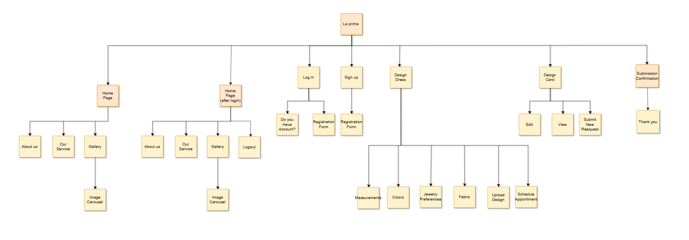
Organized by hierarchical order the Site Map reveals how all components connect through transparent navigation pathways. Through page organization and relationship management the Site Map helps users and developers grasp the website's structure and operational design.

The purpose of the Site Map is to:
The document provides complete details about the website layout.
Help the development team develop all needed web pages together with required features.
Users will have a pleasant experience when they operate the platform because you have made navigation elements easy to understand and smooth to use.
Key Sections in the Site Map:
Homepage:
Divided into two states:
- Before Login: Features options like Login and Sign Up.
- After Login: Throughout the site System enables registered users to log out and obtain personalized website elements.
Main sections:
About Us: Displays information about the website or company.
Our Services: Highlights the available services.
Gallery: Showcases images in a carousel format.
Login and Sign-Up Pages:
When users log in new users can create an account through the Sign-Up page as they complete a registration form.
Customization Page (Design Dress):
Platform users can transform orders through measurement selection and material choices alongside colour options and design uploads and appointment reservation.
User Dashboard (Design Card):
Through this web page users can make profile modifications alongside looking at past product demands and sending fresh ones.
Submission Confirmation Page:
Submissions trigger a thank-you notification whenever users finish completing requests or forms.
Logout:
The system allows users to perform account logouts through a secure method
The Site Map allows users to find website features seamlessly which creates an easygoing user experience.

Wireframes

Website and Phone Design:
Home page1:
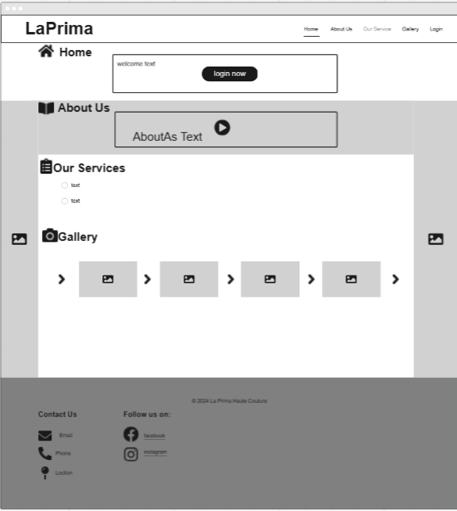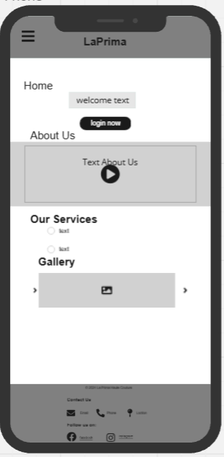
LogIn page:
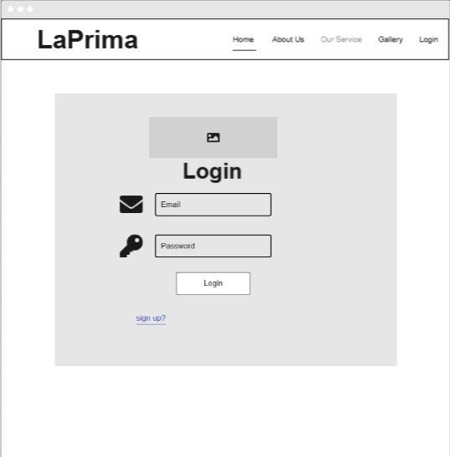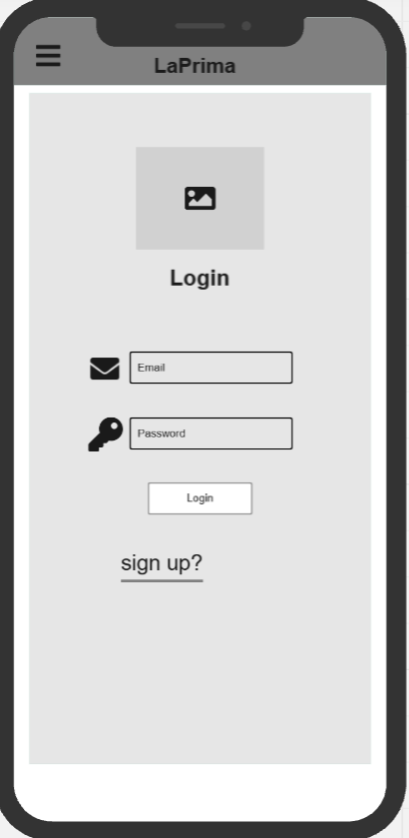
Sign Up Page:
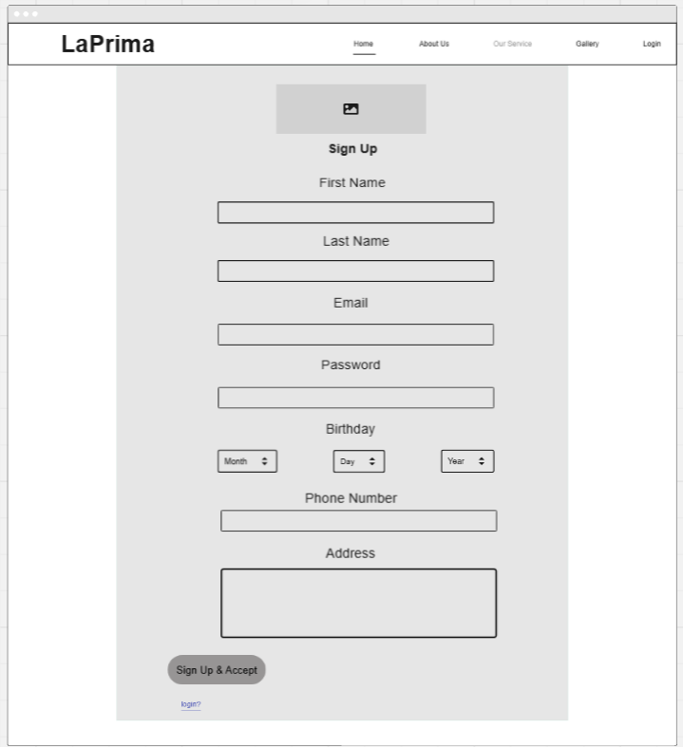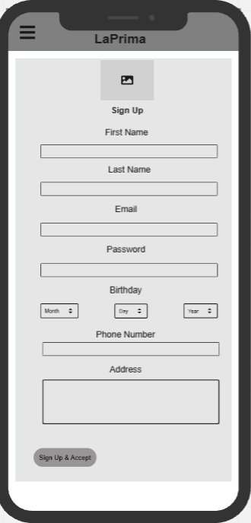

Page home after login:
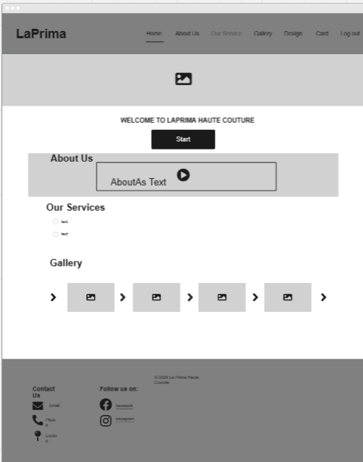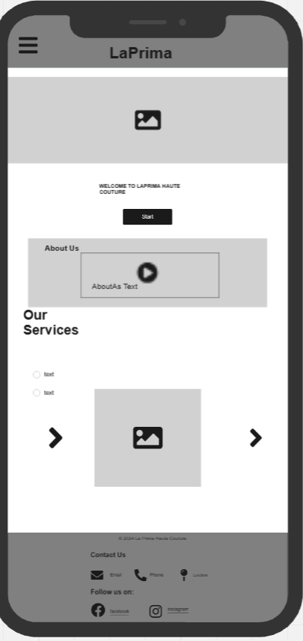
Design Dress Page:
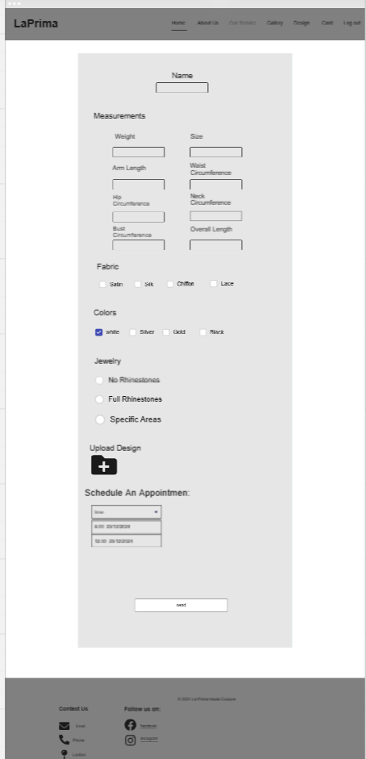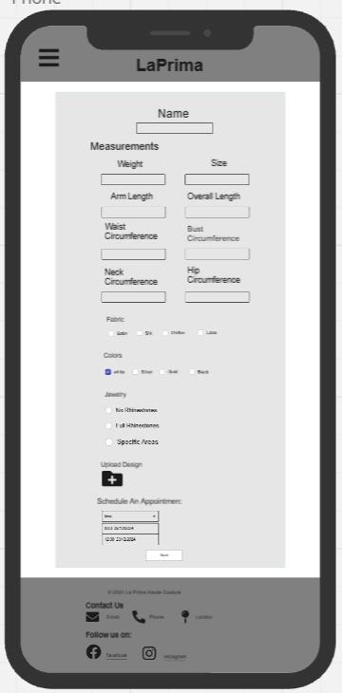

Dress Card Page:
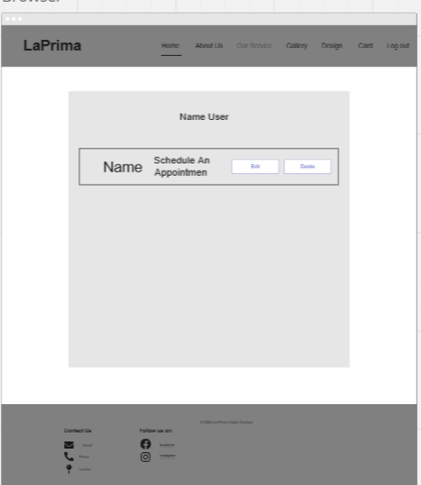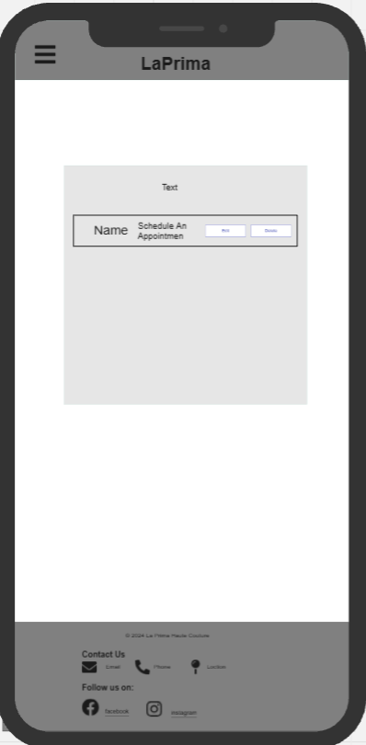

Submitted page:
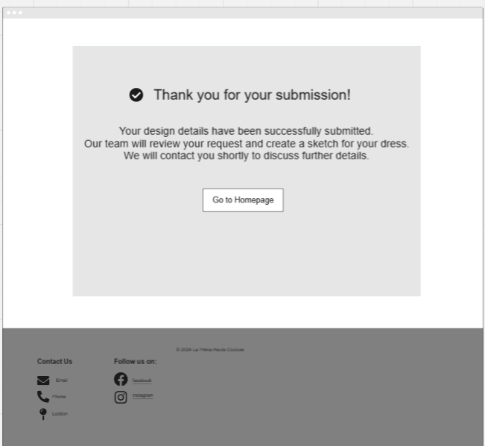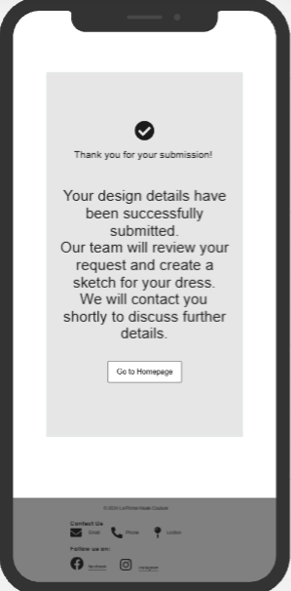

Website Wireframes
The visual presentation called wireframes marks the starting point for building website structures and arranging website elements. Wireframes provide developers along with stakeholders visual direction about interface design to help them visualize both component placement and complete UX interactions.
The fundamental reason to develop wireframes centers around discovering a page's most important organizational fit for key components which include navigation menus buttons forms and images. The first visual depiction of plans through wireframes reinforces user convenience by providing clear layouts to help teknorapide guide website development works toward specified objectives.
The platform Miro enabled the generation of wireframes for our project. The interactive features of Miro's platform helped users quickly restructure their design choices while simultaneously working towards both planning and execution of the website's structure.

Each wireframe corresponds to a page or feature in the website:

The Home Page:
Is divided into two versions. The first version is for users who are not logged in, featuring a "Login" button and sections like "About Us," "Our Services," and "Gallery," which includes an image carousel. The second version, displayed after login, replaces the "Login" button with "Logout" and provides additional navigation options for registered users.

The Login Page:
Provides fields for users to enter their email and password, along with a "Sign Up?" link for new users. It’s designed to be simple and user-friendly, ensuring smooth access to accounts.

The Sign-Up Page:
Contains a detailed registration form. Users can input their first name, last name, email, password, date of birth, and phone number. This page ensures that new users can create accounts effortlessly.

The Design Dress Page:
Offers users the ability to customize their orders. This includes inputting measurements like weight and size, selecting fabric types and colors, specifying jewelry preferences, uploading custom designs, and scheduling appointments.

The Design Card Page:
Functions as a user dashboard. It allows users to edit existing designs, view submitted requests, and start new submissions, offering full control over their customization projects.

The Submission Page:
Confirms the completion of a user's request. It includes a thank-you message and a "Go to Homepage" button to redirect users after submission.

Each wireframe is directly connected to the Site Map. For example, the "Customization" section outlined in the Site Map is represented visually through the Design Dress Page wireframe, showing detailed options for measurements, fabric, and scheduling. Similarly, the Login and Sign-Up Pages in the Site Map are reflected in simple, functional designs in the wireframes.
The website structure requires proper alignment of user needs through wireframe tools. Wireframes help keep projects focused and become an efficient design model which guarantees page consistency throughout all stages of development. Wireframes function as the critical bridge between design fundamentals and active website construction through which successful platforms develop.

Website:
Page Home:
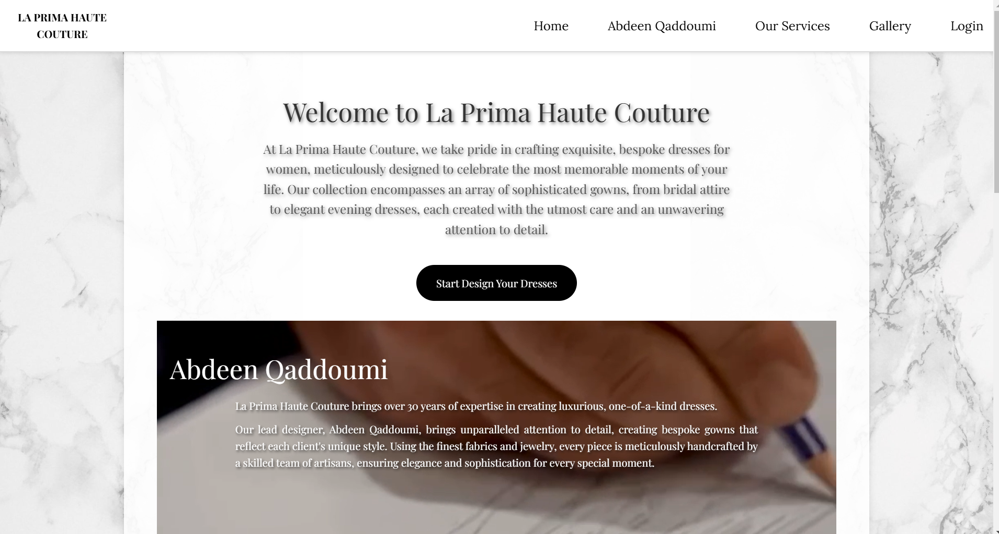
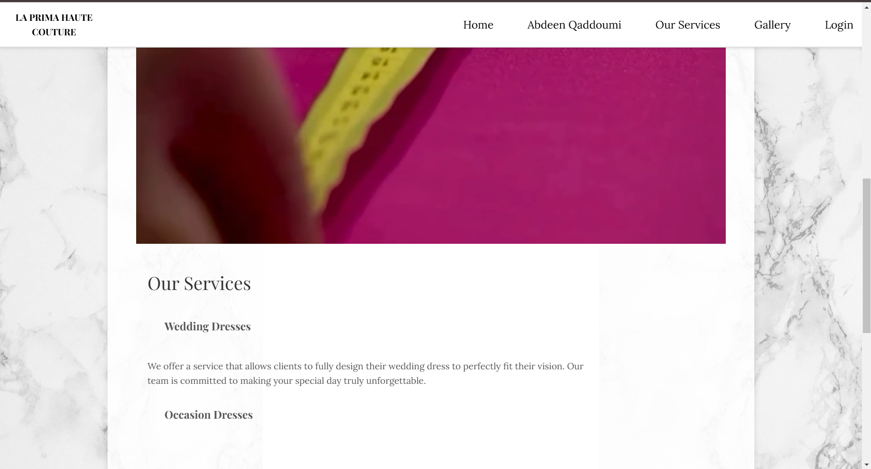
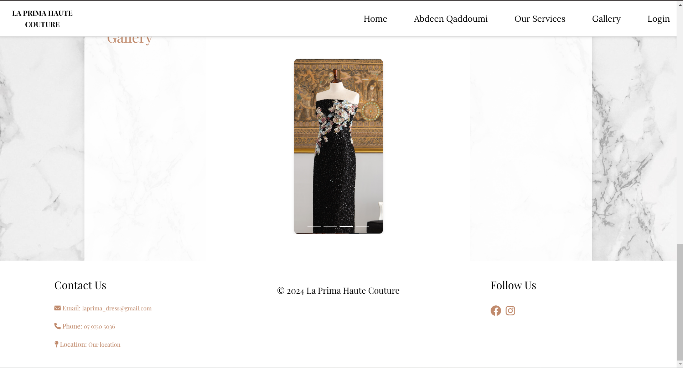
Page Login:

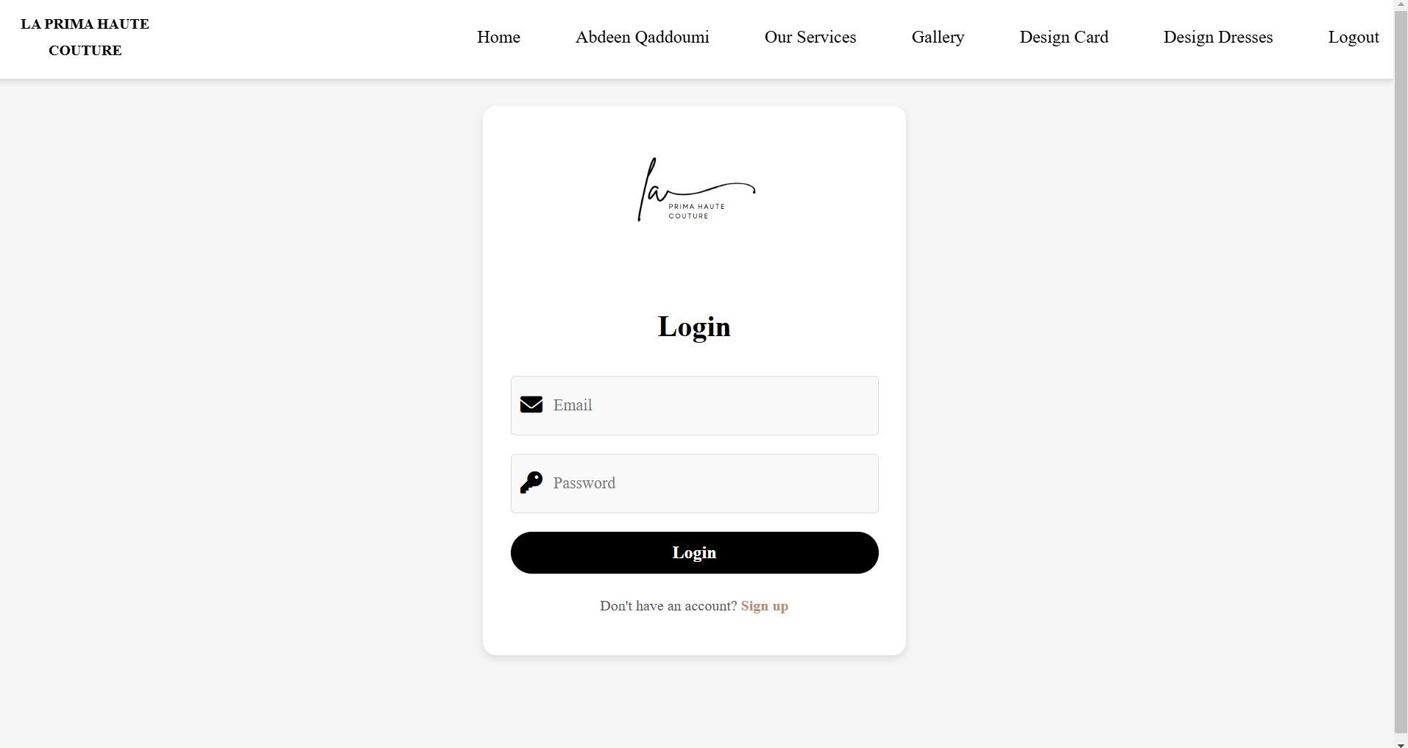
Page Sign Up:
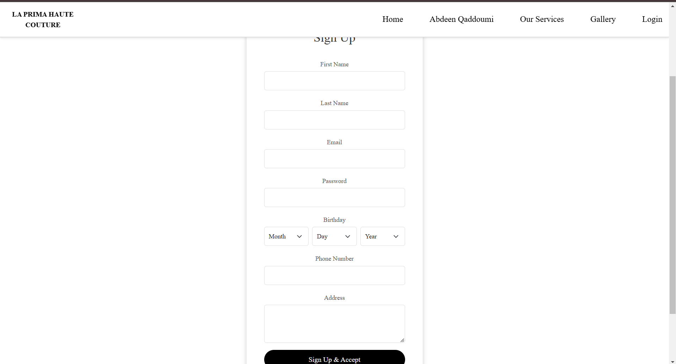
Page Home2:
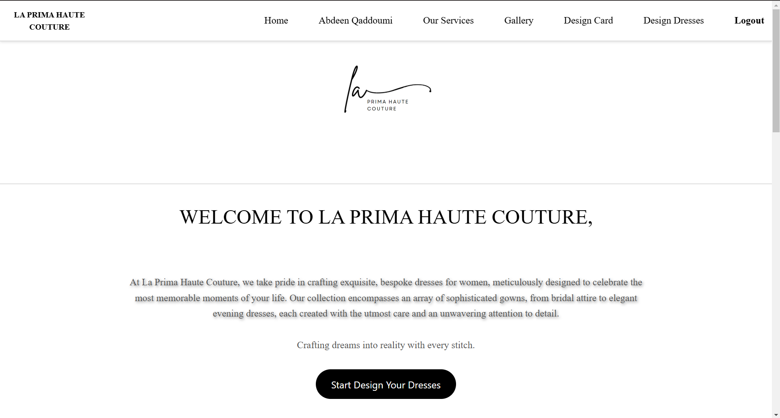
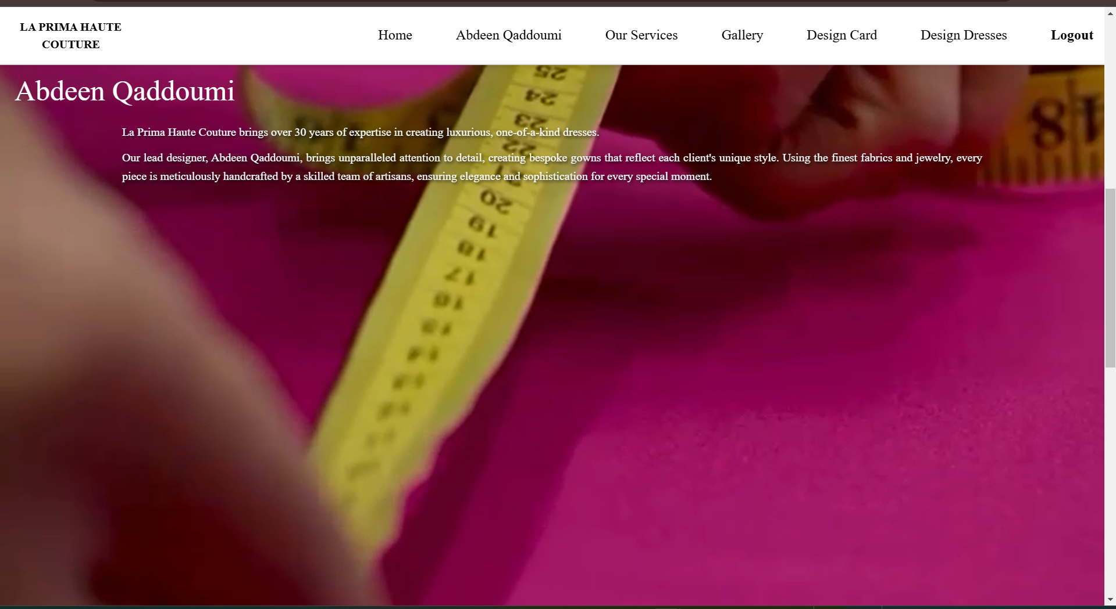
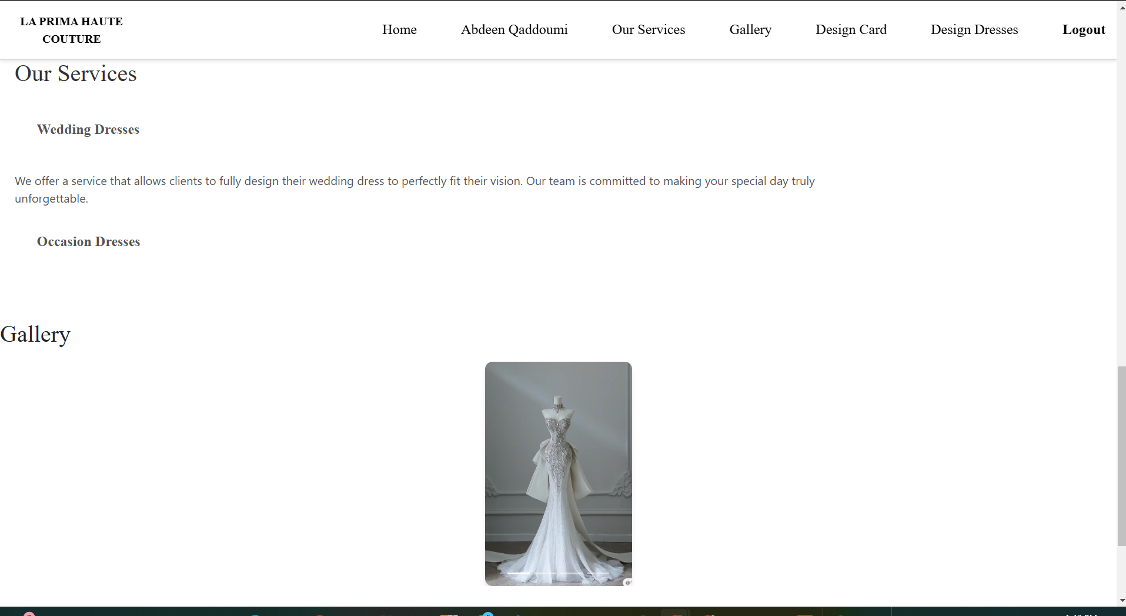
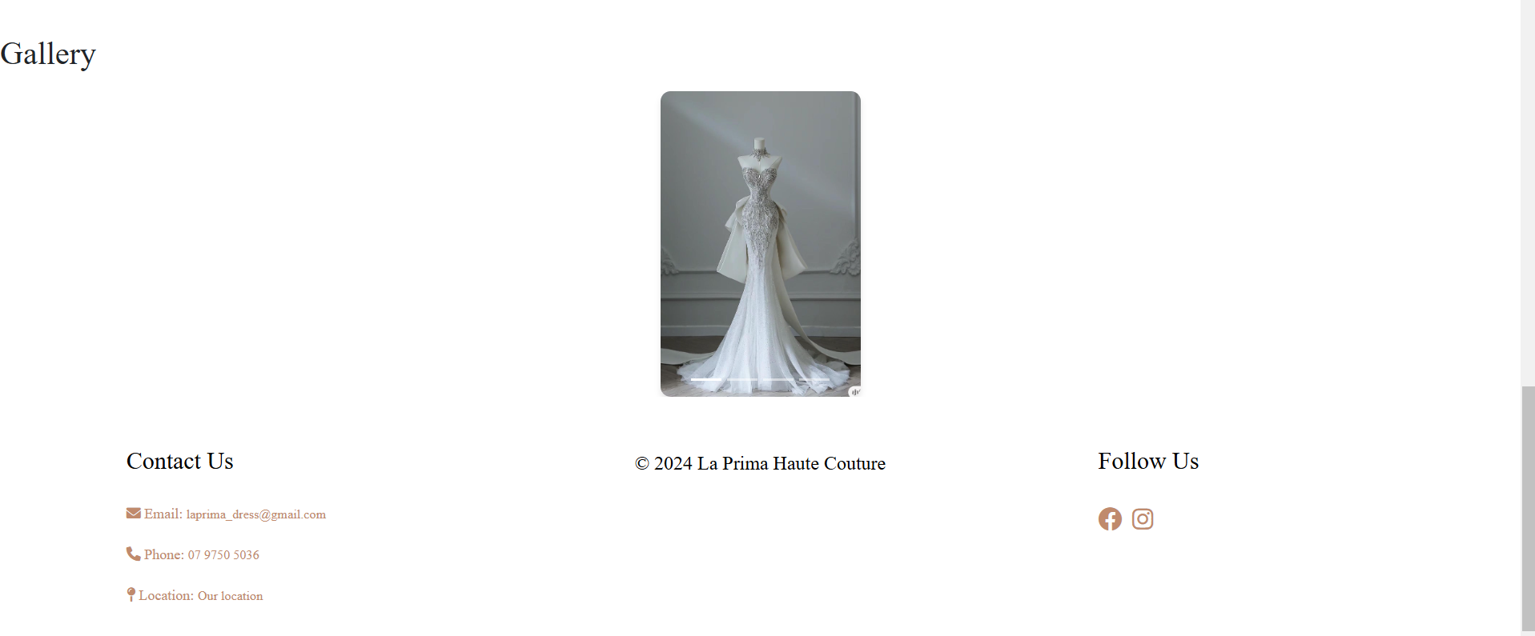
Page Design Dress:
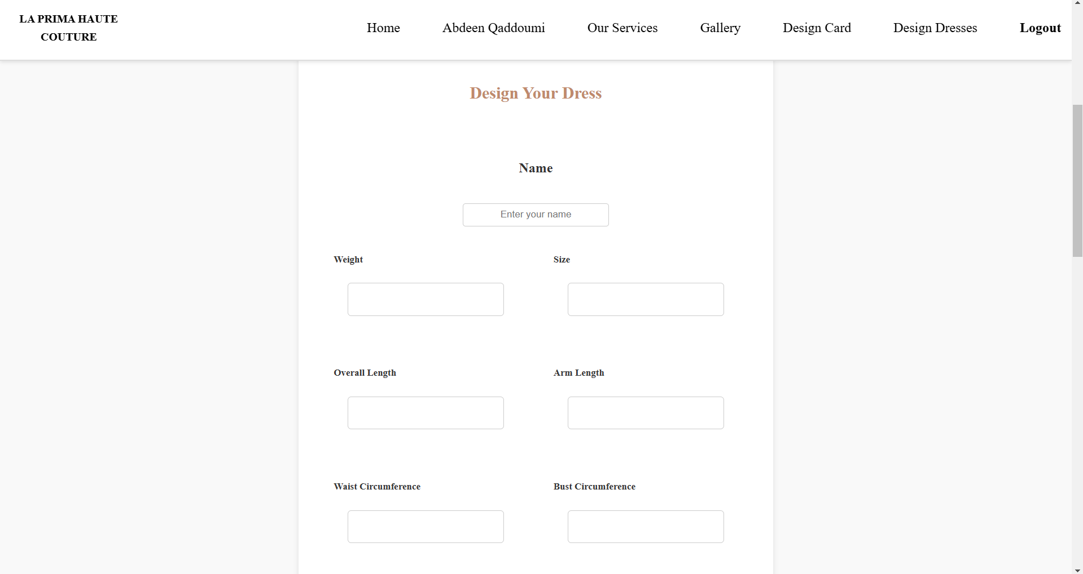
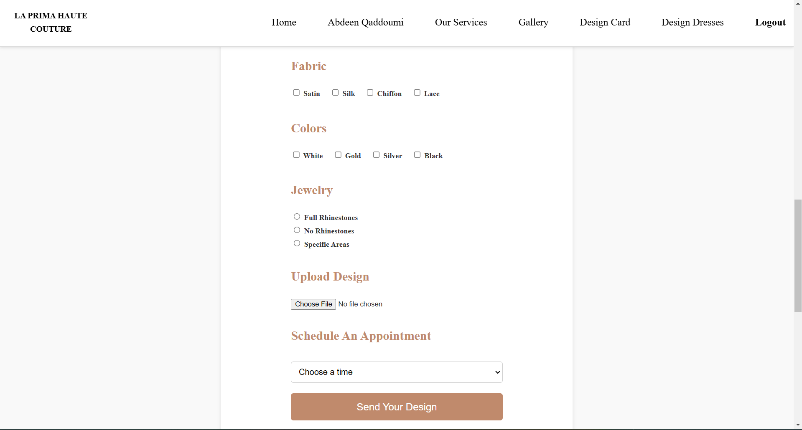

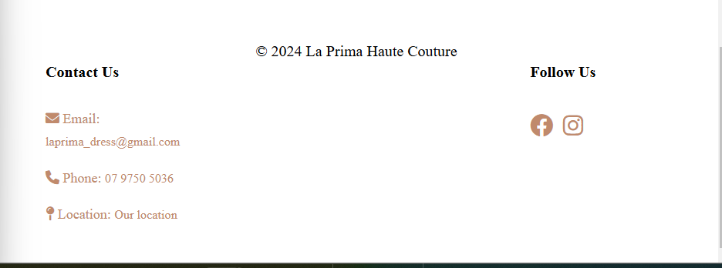
Page Design Card:
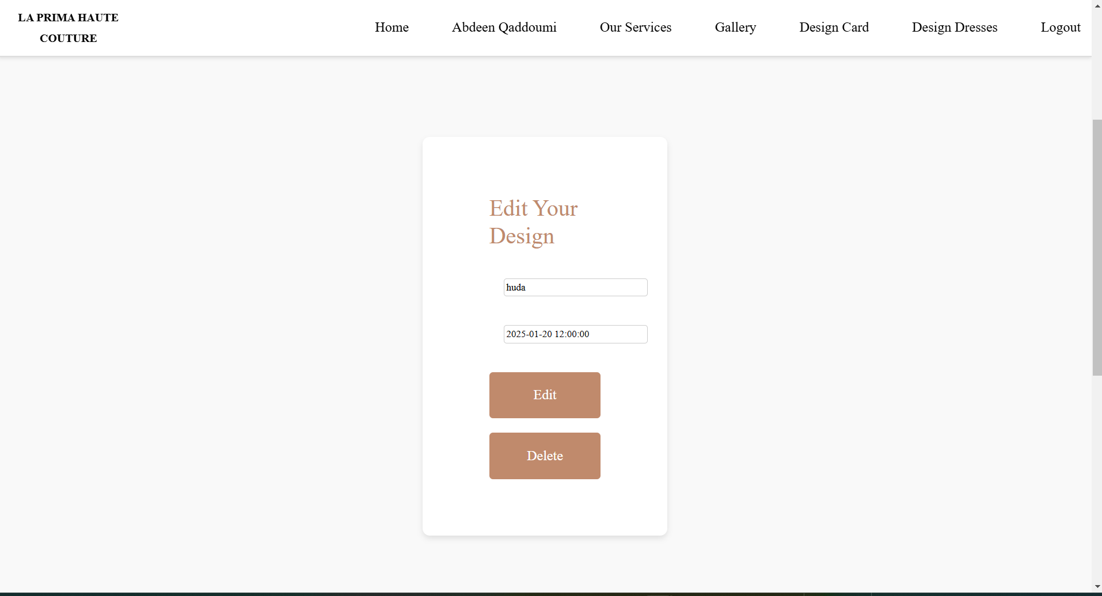

Page Submit:
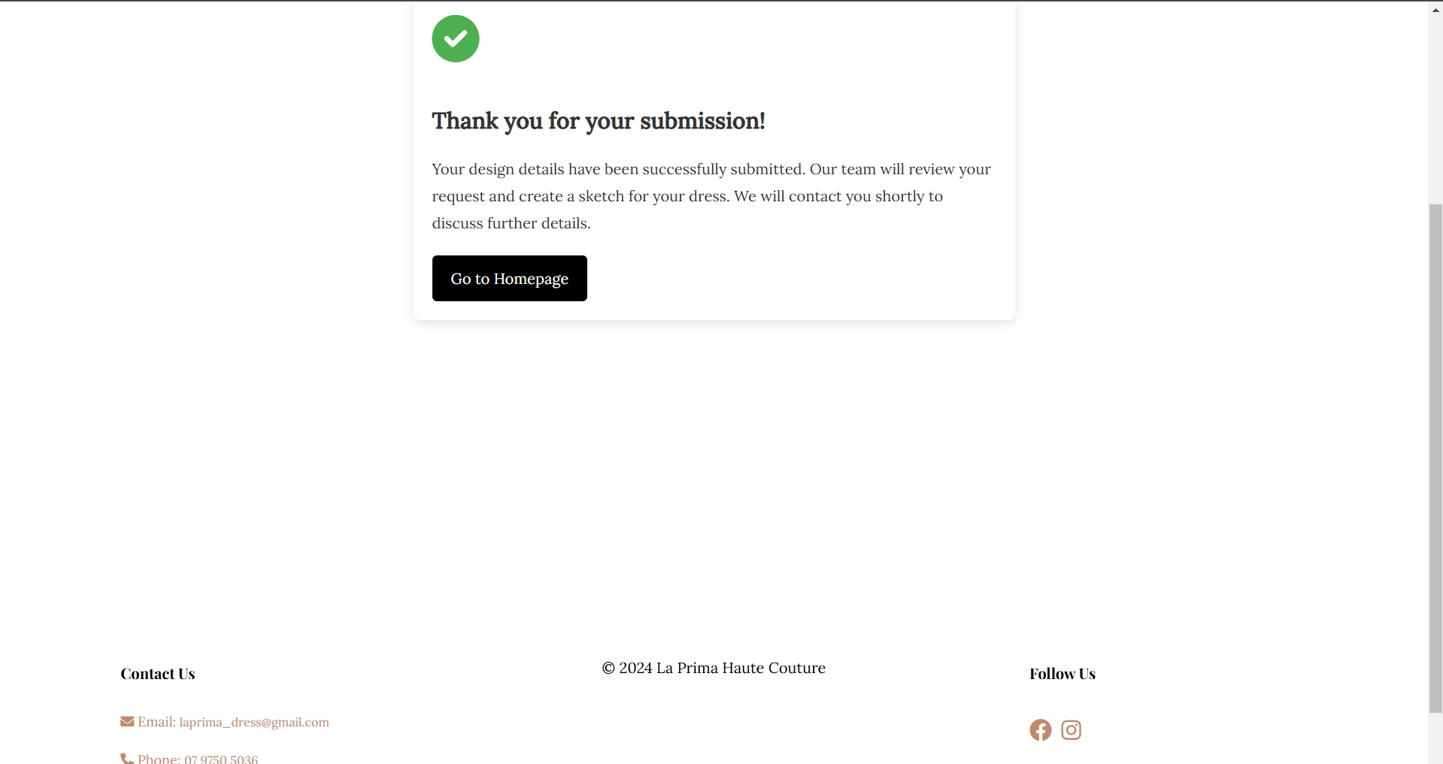

Website vs Design Document
1. Website Explanation (Website):
LaPrima developed a user-friendly interactive website that enables platform users to personalize their custom dress designs through scheduling options. The website includes various features such as:
Homepage: The homepage gives website tours with user authentication options for signed-in and casual viewers.
Login and Sign-up Pages: Users can both gain access to existing accounts and establish new accounts.
Customization Page: Through the platform users obtain full control to determine their dress dimensions along with fabric selections and coloring choices and preferred jewelry combinations.
User Dashboard: Through this interface users can both edit their profiles and their designs and submit new orders.
Submission Confirmation Page: The success confirmation shows users a thank-you note. The website adheres to the planned structure, with a focus on mobile responsiveness, intuitive navigation, and fast performance.
2. Design Document Explanation (Design Document):
The design document created an exhaustive plan which guided the website's development process. It included:
Site Map: The Site's structure exists in a hierarchical format which diagrams principal pages while displaying their mutual connections.
Wireframes: The design document evidenced every page visually through its arrangement structure for buttons and forms alongside images. A design document functions as a reference guide that both supports the alignment of user requirements and design objectives and maintains a dual purpose for aesthetics and program function.
Criteria | Design Document | Website Explanation | Note
Purpose | The website requires a blueprinted structure that includes necessary features. | Functionality exists throughout the website which delivers all intended user features. | The website demonstrates complete attainment of design objectives.
Page | Preliminary designs for the homepage, login, and customization pages. | The system incorporates pages which include fully developed content alongside responsive user interfaces that work across multiple platforms. | The implementation keeps the original design layout intact.
Functionality | All essential website elements including login functionality alongside dress design functionality exist. | All designed system functions exist in their entirely. | Features work as expected.
Consistency | The project features planned designs that determine color schemes alongside typefaces together with page arrangement schemes. | A consistent application of both colors and fonts exists between all web pages. | The visual alignment throughout the system stands out as clear and strong.
User Experience (UX) | Initial ideas about user flow and interactions with the website. | A better interface design emerges from responsive functionality paired with easy navigation. | Better mobile usability has been implemented through recent design enhancements.
Challenges | Predicted design and functionality challenges. | The team experienced genuine database connectivity limitations when developing the project in reality. | Challenges were successfully resolved.

3. Visual Evaluation
- Colores and Fonts:
A professional visual style was preserved through the consistent use of design document colours and fonts throughout all pages.
- Layout:
The final implementation used original wireframe components while adding refined user journey improvements to each element.
Design elements received proper margin and spacing management which keeps content suitable for different screen dimensions.
- Responsiveness:
The last design executes fully responsive capabilities so users gain identical website experience across mobile screens and tablets. These designs included improvements compared to wireframes by focusing primarily on desktop user experience.

The implemented website showcases all elements from the originally designed structures while including operational features described in the document. Implementations made to the completed website show design consistency versus wireframes through modifications that optimized user interface and adaptive design features. Better usability emerged from these modifications because they enhanced user experience while staying consistent with the fundamental design targets.

Evaluation and Analysis
Section Purpose:
This section covers the review of the website by analyzing its features, development challenges, and focuses on the main Dress Design Feature of the website.
Dress Design Feature:
Main Functionality:
- The Dress Design Feature allows the user to create a unique and personalized design by selecting the following:
- Fabric Type - silk, cotton, linen, chiffon.
- Some of the designs created by users for dresses on this website.
- Users can choose between colour schemes with pattern options to customize designs, and choose, like any Jewellery.
Design Enhancements to Include:
1. Interactive Tool to Design:
The website accessibility will provide real-time users design changes with the help of integrated interfaces.
- Give some additional options to include:
Stitching with text or signs.
Users can easily pick the right measurement with the help of an embedded tape measure.
2. Integrate Dress Design with Booking Choice:
- Book it with the Designer:
Customers who finish their design would make an appointment to confirm specifications with the designer before going further.
- Order Submission:
The website has the facility for automatic submission of details of the final designs as and when the users submit their work directly. It gets stored in a database and transmitted at the designer's end.
3.Live Communication with the Designer:
Your platform should provide the live chat option along with the contact form to the users because such features enable the customer to reach the designer for information at design stages.
4.Enhancing User Experience in Design Page:
The interface needs dynamic CSS implementations so that it looks more attractive.
Users will be able to enable hover effects once they hover over buttons and will also be allowed to customize the interface elements.

Challenges Faced:
Smoother Dress Designing Process:
Problem: Making the interface user-friendly in function for each of the features of customization was a big challenge.
Solution: The team did develop an interface that showed real-time viewpoints while segmenting design choices into observable step-by-step instructions through an interactive system.

Managing User Data and Customization Requests:
Problem: Storing the designs made by users while not compromising on secure system architecture.
The database was well structured, whereby in it, user design specifications were connected to online accounts.
Future Recommendations:
- 3D Preview Feature:
Allow users to preview their designs in 3D so that all the details could be double-checked for accuracy before going ahead with the submission.
- Increase Integration of More Payment Options:
Users will get free appointments or may pay for pre-made dresses.
- Pre-Made Dresses Available:
The user will see a list of ready-to-wear dresses that the designer has and can be directly purchased.
- Advanced Customization Options:
Add the option to change the sleeves, length, and side slits of a design to make it even better.

The Dress Design Feature forms one of those USPs in which the benefit to the users is well pinpointed. In fact, the feature may be positioned as an offering by the platform for all needs of users by further enhancements, such as the interactive preview of designs, option to book, and options for advanced customization.

Hosting (Add your domain and URL)
Add your domain and URL:
laprimacouture.kesug.com
Specify which hosting server you use
Hosting Server:
The website "laprimacouture.kesug.com" runs on hosting under kesug.com domain which provides page-hosting capabilities across multiple pages.

Reason for choosing hosting:
A hosting service was selected because it makes it simpler to prepare advanced technologies that allow website page hosting and specific custom designs. Hosting establishes a dependable stable network that enables precise site determination.

Hosting advantages:

Users can access the subdomain "kesug.com" directly through their main kesug.com domain.
Easy access to the site over the Internet.
Page loading exists alongside rapid page loading speed as a major concern.
HTTPS allows traffic encryption to secure communications between users and servers

Add screenshots
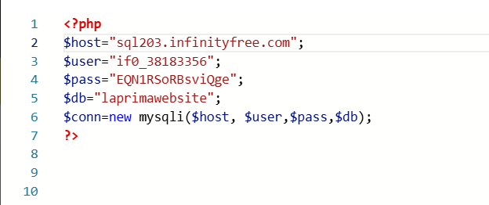
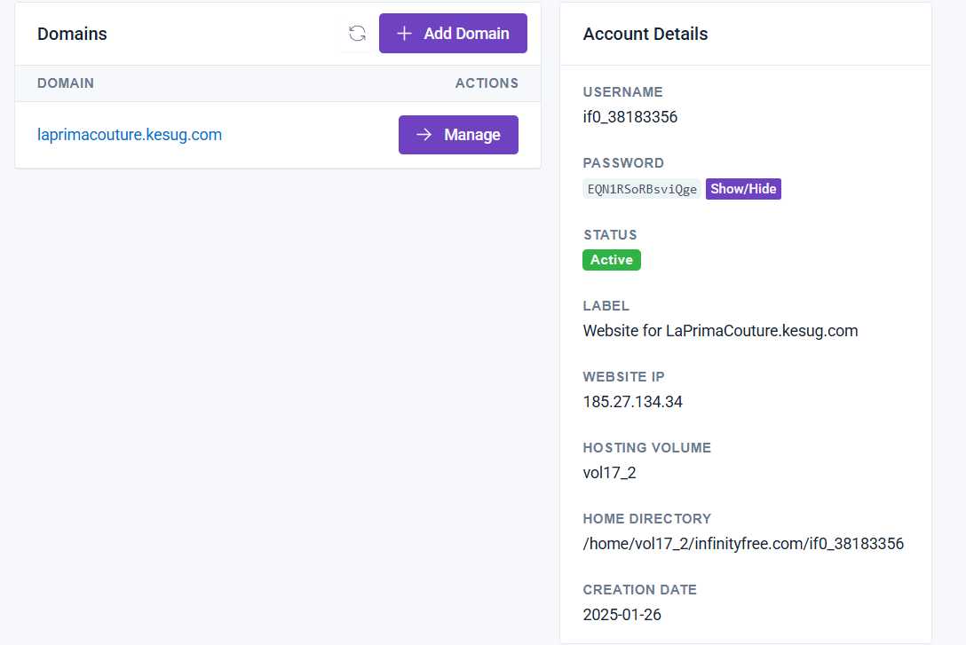

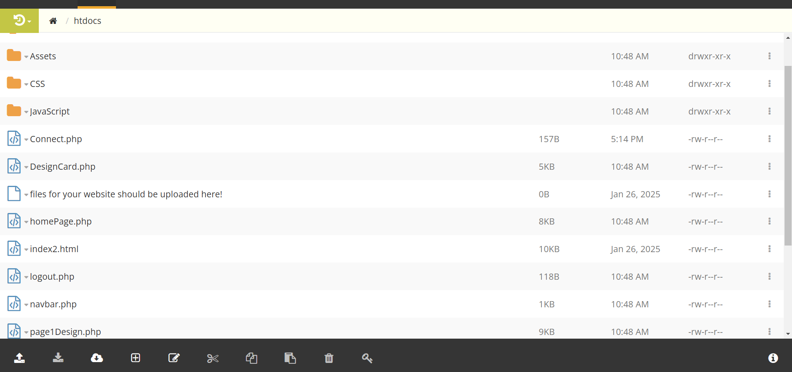
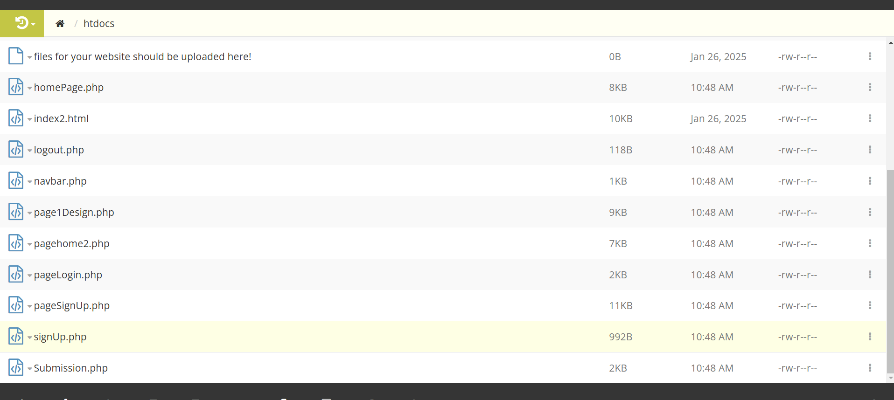

References

- JasonGerend (n.d.). Domain Name System (DNS). [online] learn.microsoft.com. Available at: https://learn.microsoft.com/en-us/windows-server/networking/dns/dns-top.
- ICANN (2024). What Does ICANN Do? - ICANN. [online] www.icann.org. Available at: https://www.icann.org/resources/pages/what-2012-02-25-en.
- CLOUDFLARE (2019). What is DNS? | How DNS works. [online] Cloudflare. Available at: https://www.cloudflare.com/learning/dns/what-is-dns/.
- Cloudflare.com. (2024). What is SSL (Secure Sockets Layer)? [online] Available at: https://www.cloudflare.com/learning/ssl/.
- Documentation Group (2019). Documentation: Apache HTTP Server - The Apache HTTP Server Project. [online] Apache.org. Available at: https://httpd.apache.org/docs/.
- dknappettmsft (2022). Get started with Windows Server. [online] learn.microsoft.com. Available at: https://learn.microsoft.com/en-us/windows-server/get-started/get-started-with-windows-server
- www.w3schools.com. (n.d.). What is a Front-End Developer. [online] Available at: https://www.w3schools.com/whatis/whatis_frontenddev.asp.
- GeeksforGeeks (2023). Backend Development Complete Guide. [online] GeeksforGeeks. Available at: https://www.geeksforgeeks.org/backend-development/.
- Amazon Web Services, Inc. (2023). Front End vs Back End - Difference Between Application Development - AWS. [online] Available at: https://aws.amazon.com/compare/the-difference-between-frontend-and-backend/?utm_source=chatgpt.com.
- Coursera (2022). UI vs. UX Design: What’s the Difference? [online] Coursera. Available at: https://www.coursera.org/articles/ui-vs-ux-design.
- https://careerfoundry.com/en/blog/ux-design/the-difference-between-ux-and-ui-design-a-laymans-guide/
- Stevens, E. (2022). UX vs. UI design: What’s the difference? - UX Design Institute. [online] www.uxdesigninstitute.com. Available at: https://www.uxdesigninstitute.com/blog/ux-vs-ui-design/.

